Evidence-Based Intervention Planning for the DNP Project

Tess Walde
Midwestern University
1502: The Scientific Underpinnings of the DNP
Dr. Mary Heider
October 12, 2025

Statement Refinement
Problem Statement
Persons who use substances entering the British Columbia (BC) correctional system frequently experience suboptimal management of substance withdrawal syndromes (Torres-Lockhart et al., 2022). Prescribing practices incongruent with clinical guidelines decrease retention in harm-reduction strategies, increase diversion within correctional centers, and increase recidivism rates (Butler, 2021).
Purpose Statement
The DNP quality improvement project (QIP) will develop, introduce, and evaluate standardized pre-printed order (PPO) protocols to manage opioid and benzodiazepine withdrawal for individuals entering BC Corrections. Informed by Orem's Self-Care Deficit Nursing Theory, the writer's transformational-servant leadership style will enact change through Kotter’s Eight-Step Change Model (Divya & Suganthi, 2017; Harrison et al., 2021; Hartweg & Metcalfe, 2021). This guideline-based approach will enhance patient outcomes, promote adherence to harm reduction strategies, reduce contraband medication diversion, reduce mortality rates, and contribute to lower rates of re-incarceration (Evans et al., 2024; Kaplowitz et al., 2022).
Clinical Questions
On-Call Service
In the BC Corrections healthcare setting, will initiating a PPO protocol for opioid/benzodiazepine withdrawal at intake reduce provider-on-call workload?
Not all BC correctional facilities have daily providers on-site, although inmates arrive every day. On-call services are accessed by intake nurses for initial opioid agonist therapy (OAT) orders, but multiple calls occur as withdrawal symptoms arise (R. Linton, personal communication, October 6, 2025). This increases workload for on-call providers and nursing staff.
Withdrawal Severity
In the BC Corrections healthcare setting, will initiating a PPO protocol for opioid/benzodiazepine withdrawal at intake result in decreased withdrawal severity?
Withdrawal from short-acting opioids can last up to eight days. Treating withdrawal symptoms early with OAT plus side-effect moderators decreases negative health outcomes and improves quality of life (CRISM, 2024).
Harm Reduction Retention
In the BC Corrections healthcare setting, will initiating a PPO protocol for opioid/benzodiazepine withdrawal at intake increase retention in OAT and harm reduction strategies?
When patient preferences are considered at OAT initiation, more inmates are retained in harm reduction strategies such as OAT upon release (Berk et al., 2025). Effective withdrawal management increases engagement in future medical care and reduces mortality risk (Torres-Lockhart et al., 2022).
PICOT Question

Population
Inmates entering the BC Corrections system who are engaged in opioid and/or benzodiazepine use prior to incarceration and are experiencing withdrawal symptoms.

Intervention
Evidence-based PPO protocols to treat opioid and benzodiazepine withdrawal syndromes.

Comparison
Without standardization, patients receive variable medication orders for substance-specific withdrawal and limited prescription of symptom moderators for nausea/vomiting, diarrhea, restlessness, irritability, confusion, insomnia, pain, etc.

Outcome
There are three outcome measurements for this project.
- Effect on Physician/Nurse Practitioner workload: Use of the provider-on-call after-hours service using weekly reports.
- Effect on patient experience: Average Clinical Opioid Withdrawal Scale (COWS) scores (BC Centre for Substance Use [BCCSU], 2023) of inmates receiving PPO withdrawal management at day two.
- Effect on patient outcomes and mortality: Percentage of inmates on OAT at Kamloops Regional Correctional Centre (KRCC) using weekly reports.

Time
Data will be collected for two weeks prior to use of the PPO. The site-wide trial will run for six weeks. The PPO will be used for six weeks by all Nurse Practitioners and Physicians providing withdrawal management orders.
Preliminary Needs Assessment
Intended Project Setting
BC Corrections utilizes the Provincial Health Services Authority (PHSA) under the BC Mental Health and Substance Use (BCCSU) Services branch for healthcare within its ten correctional facilities (McLeod et al., 2024). The healthcare units encompass a healthcare team including a part-time NP and physician group. Upon arrival, many inmates have been without substances for up to three days and are in acute withdrawal. Inmates are assessed by the intake nurse and an addictions provider initiates medication for acute opioid/benzodiazepine withdrawal if appropriate. This process was confirmed as similar province-wide (A. Skinner, personal communication, September 5, 2025).
Problems to be Addressed
Opioid Crisis. The province of BC has seen the largest number of toxic drug deaths in Canada since 2016. Highly-potent fentanyl analogues in the opioid drug supply are adulterated with benzodiazepines, creating high mortality risk with each ingestion (BCCSU, 2023). Both substances create tolerance within the user, resulting in severe withdrawal co-syndromes with abrupt cessation. New inmates experience sudden abstinence and require urgent medical support as a basic human right (McLeod et al., 2024).
High-Risk Mortality. When withdrawal is not comprehensively treated, the negative experience increases relapse and drug-poisoning rates (Berk et al., 2025). BCMHSUS does not have a standardized ordering process for withdrawal management. PPO protocols ensure consideration of patient history and preference, consistent prescribing approaches, and reduction of withdrawal symptoms (Kaplowitz et al., 2022; Wells & Loshak, 2019). Patients in BC Corrections frequently transfer between facilities. Continuity of care and patient trust will improve with PPO protocols (Wells & Loshak, 2019).
Efficiency in Corrections Healthcare Units. Fluctuating approaches to opioid/benzodiazepine withdrawal result in higher workloads for all healthcare staff (Ehringer & Duffy, 2009). Use of standardized order sets reduces mortality rates, medication errors, and time patients require to access care (Wells & Loshak, 2019).
Evidence-Based Intervention
Intervention Not Currently in Use
BCMHSUS does not have standardized opioid/benzodiazepine withdrawal PPOs for prescribers. BCCSU is a leader in evidence-based guideline development for opioid withdrawal management, publishing the first guideline worldwide in 2017. The guideline was developed by an addictions expert committee through extensive literature review and rigorous debate prior to being formalized (BCCSU, 2023). These guidelines have been adapted by the Canadian Research Initiative in Substance Matters (CRISM) for use Canada-wide (CRISM, 2024). Health authorities in BC adapted the BCCSU guidelines into acute care PPOs. In addition to the BCCSU guideline, this QIP will draw from Interior Health Authority (IHA) PPOs for guidance (IHA, 2024a; IHA, 2024b; IHA, 2025). BCMHSUS recommendations for benzodiazepine withdrawal and other evidence-based guidelines will consulted for the PPO (Dunham et al., 2025).
Relevance to PICOT Question
BCMHSUS began healthcare administration for BC Corrections facilities in 2017. BCCSU OAT prescribing was introduced through this partnership, increasing quality of life for inmates (McLeod et al., 2024). Standardization of prescribing side-effect moderators and lab work orders will reduce workload of the provider-on-call service and nursing staff, decrease inmate suffering, and increase harm reduction retention (CRISM, 2024). Orem's nursing theory of empowering patients as participants in their health outcomes is the foundation of this work (Hartweg & Metcalfe, 2021).
Permission Consideration
Location of QIP Trial
Kamloops Regional Correctional Centre is located in Kamloops, BC and houses up to 373 inmates (BC Corrections, n.d.).
Ethics Considerations
The BC Corrections Research Application Committee is responsible for reviewing, approving, and overseeing all research projects within BC correctional facilities. An application is required for primary data collection through patient or staff interactions and to view data for research purposes. This QIP requires access to information in the BCMHSUS electronic medical record (BCMHSUS, 2022).
Evidence of a Request
This writer has requested guidance from BCMHSUS Data Access Coordinator regarding likelihood of populating pertinent data from the current EMR. The submitted aggregate data request form with attached project outline can be seen in Appendix A. Access to health data held by BCMHSUS must be requested through their research committee via the Data Access Request online form. This QIP requires access to data for project development and analysis. Prior to implementation, the research committee must also approve the six-week QIP trial at KRCC. See Appendix B. Criteria for this application includes clearance from the Midwestern University’s ethics committee prior to submission of the data access request (BCMHSUS, 2022).
Conclusion
The DNP QIP will increase the welfare of inmates experiencing opioid/benzodiazepine withdrawal syndromes through use of evidence-based PPO protocols. Benefits will be seen in decreased health unit workload and withdrawal severity with increased inmate retention in harm reduction modalities. Guidelines and pre-existing PPOs will be adapted to the corrections setting. This PPO will be trialed for six-weeks at KRCC after approval by the BCMHSUS Research Committee.
References
BC Corrections. (n.d.). Kamloops regional correctional centre. https://www2.gov.bc.ca/assets/gov/careers/for-job-seekers/current-bc-government-job-postings/featured-careers/corrections_recruitment_kamploops.pdf
Berk, J., South, A.-M., Martin, M., James, M.-E., Miller, C., Haber, L., & Rich, J. (2025). Medication for opioid use disorder service delivery in carceral facilities: Update and summary report. Health & Justice, 13(1), 8. https://doi.org/10.1186/s40352-025-00317-9
British Columbia Centre on Substance Use. (2023). A guideline for the clinical management of opioid use disorder: 2023 update. https://www.bccsu.ca/wp-content/uploads/2023/12/BC-OUD-Treatment-Guideline_2023-Update.pdf
British Columbia Mental Health and Substance Use Services. (2022). BCMHSUS research operational approval to conduct research: Guidelines. https://www.phsa.ca/researcher/Documents/BCMHSUS%20Research%20Operational%20Approval%20Guidelines%20%28July%202022%29.pdf
Butler, A. (2021). Mental health needs, substance use patterns, and risk of reincarceration among adults admitted to provincial prisons in British Columbia, Canada (etd21737) [Doctoral thesis, Simon Fraser University]. Summit Research Repository. http://summit.sfu.ca/_flysystem/fedora/2022-11/etd21737.pdf
Canadian Research Initiative in Substance Matters. (2024). Update to national guideline for the clinical management of opioid use disorder. https://crism.ca/wp-content/uploads/2024/11/2024-Update-to-CRISM-Update-to-National-OUD-Guideline-20241111.pdf
Divya, S., & Suganthi, L. (2017). Influence of transformational-servant leadership styles and justice perceptions on employee burnout: A moderated mediation model. International Journal of Business Innovation and Research, 15(1), 119–135. https://doi-org.mwu.idm.oclc.org/10.1504/IJBIR.2018.088475
Dunham, K., Mathew, M., Cheema, K., Vandewiel, M., Jones, L., Rivest, K., Bonis, J., Kahan, M., & Wyman, J. Withdrawal management services toolkit. https://www.metaphi.ca/wp-content/uploads/ToolkitWMS.pdf
Ehringer, G., & Duffy, B. (2009). Promoting best practice and safety through preprinted physician orders. Journal of Medical Regulation, 95(1), 25–35. https://doi-org.mwu.idm.oclc.org/10.30770/2572-1852-95.1.25
Evans, E. A., Pivovarova, E., Senthilkumar, R., Rottapel, R. E., Stopka, T. J., Santelices, C., Ferguson, W. J., & Friedman, P. D. (2024). Diversion of medications to treat opioid use disorder: Qualitative findings from formerly incarcerated adults in Massachusetts. International Journal of Drug Policy, 122, Article 104252. https://doi.org/10.1016/j.drugpo.2023.104252
Harrison, R., Fischer, S., Walpola, R. L., Chauhan, A., Babalola, T., Mears, S., & Le-Dao, H. (2021). Where do models for change management, improvement and implementation meet? A systematic review of the applications of change management models in healthcare. Journal of Healthcare Leadership, 2021(13), 85–108. https://doi-org.mwu.idm.oclc.org/10.2147/JHL.S289176
Hartweg, D. I., & Metcalfe, S. A. (2021). Orem's self-care deficit nursing theory: Relevance and need for refinement. Nursing Science Quarterly, 35(1), 70–76. https://doi-org.mwu.idm.oclc.org/10.1177/08943184211051369
Interior Health Authority. (2024). Methadone titration or continuation for opioid use disorder in acute care. Interior Health Authority.
Interior Health Authority. (2024). Slow release oral morphine (SROM, Kadian) titration or continuation for opioid use disorder in acute care. Interior Health Authority.
Interior Health Authority. (2025). ED opioid use disorder interim management – Adult (17 years of age or older). Interior Health Authority.
Kaplowitz, E., Truong, A. Q., Berk, J., Martin, R. A., Clarke, J. G., Wieck, M., Rich, J., & Brinkley-Rubinstein, L. (2022). Treatment preference for opioid use disorder among people who are incarcerated. Journal of Substance Abuse Treatment, 137, Article 108690. https://doi-org.mwu.idm.oclc.org/10.1016/j.jsat.2021.108690
McLeod, K. E., Butler, A., Martin, R. E., & Buxton, J. A. (2024). “Just clearly the right thing to do”: Perspectives of correctional services leaders on moving governance of health-care in custody. International Journal of Prison Health, 20(3), 299–312. https://doi.org/10.1108/IJOPH-08-2023-0052
Torres‐Lockhart, K. E., Lu, T. Y., Weimer, M. B., Stein, M. R., & Cunningham, C. O. (2022). Clinical management of opioid withdrawal. Addiction, 117(9), 2540–2550. https://doi.org/10.1111/add.15818
Wells, C., & Loshak, H. (2019). Standardized Hospital Order Sets in Acute Care: A Review of Clinical Evidence, Cost-Effectiveness, and Guidelines. Canadian Agency for Drugs and Technologies in Health. http://www.ncbi.nlm.nih.gov/books/NBK546326/

Appendix A: PHSA BCMHSUS Aggregate Data Request Application
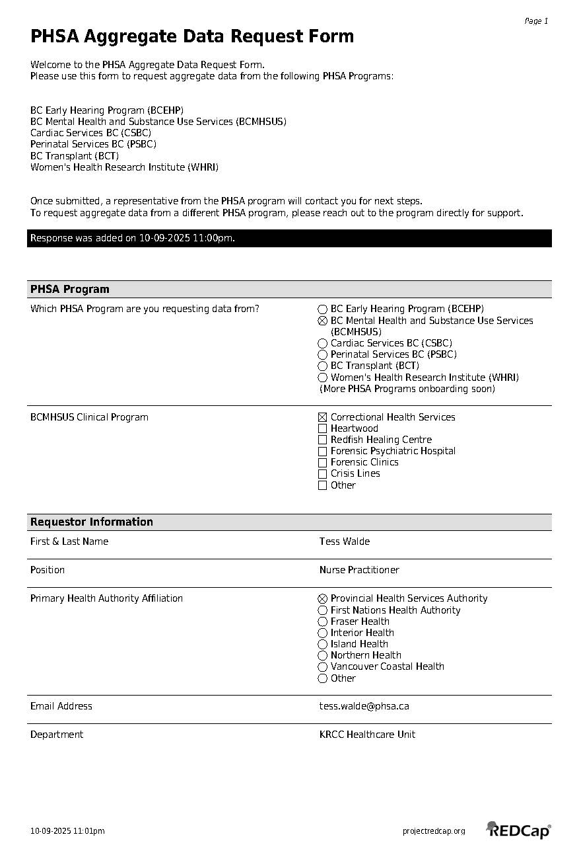
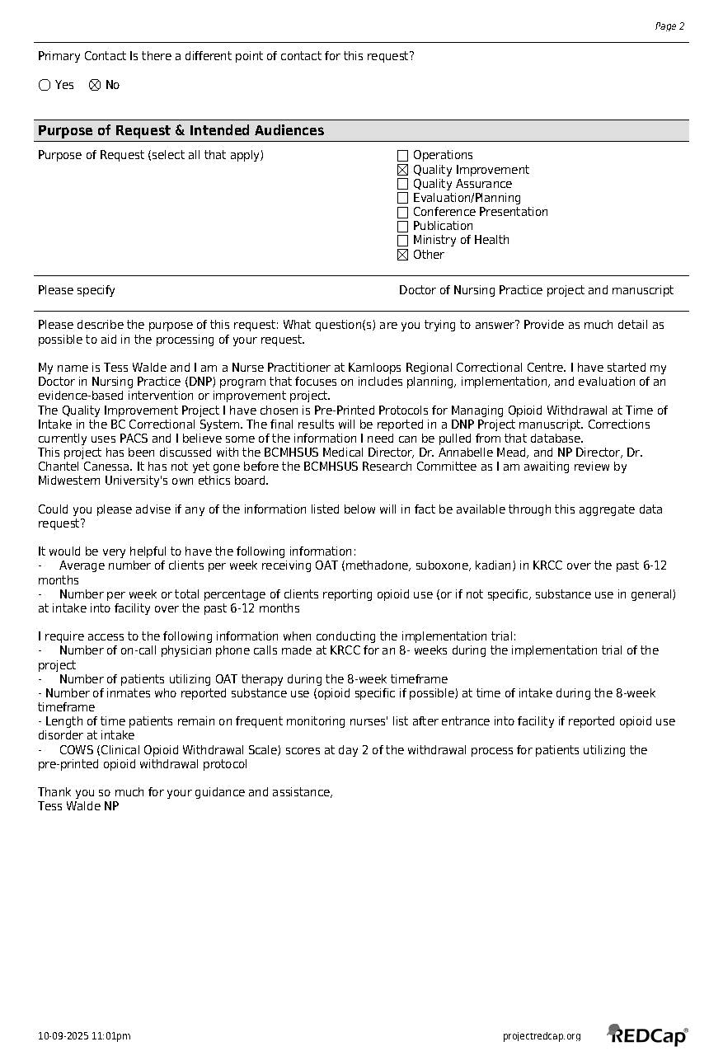
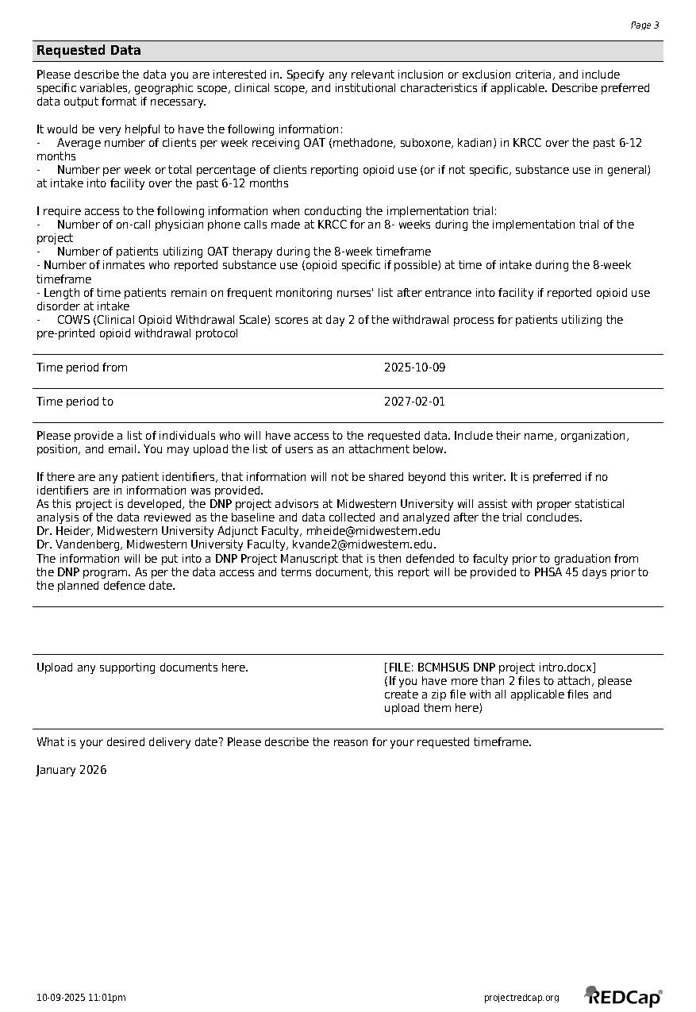
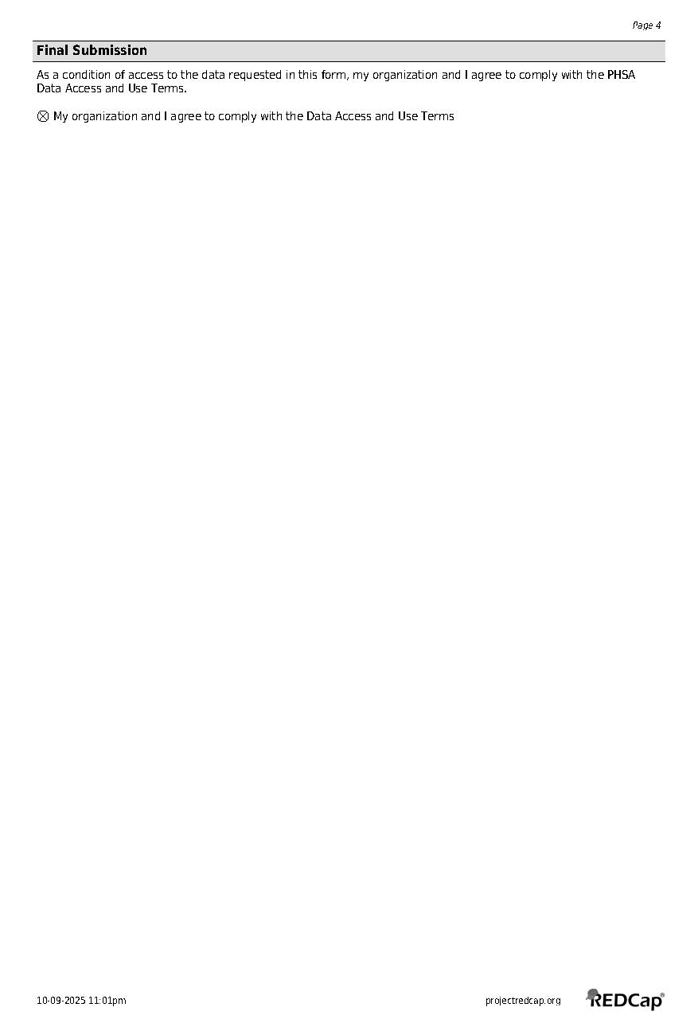

To whom it may concern;

My name is Tess Walde and I am a Nurse Practitioner at Kamloops Regional Correctional Centre. I have started my Doctor in Nursing Practice (DNP) program that focuses on includes planning, implementation, and evaluation of an evidence-based intervention or improvement project.

The Quality Improvement Project I have chosen is Pre-Printed Protocols for Managing Opioid Withdrawal at Time of Intake in the BC Correctional System. The final results will be reported in a DNP Project manuscript. Corrections currently uses PACS and I believe some of the information I need can be pulled from that database.

This project has been discussed with the BCMHSUS Medical Director, Dr. Annabelle Mead, and NP Director, Dr. Chantel Canessa. It has not yet gone before the BCMHSUS Research Committee as I am awaiting review by Midwestern University’s own ethics board.

Could you please advise if any of the information listed below will in fact be available through this aggregate data request?

It would be very helpful to have the following information:

Average number of clients per week receiving OAT (methadone, suboxone, kadian) in KRCC over the past 6-12 months

Number per week or total percentage of clients reporting opioid use (or if not specific, substance use in general) at intake into facility over the past 6-12 months

I require access to the following information when conducting the implementation trial:

Number of on-call physician phone calls made at KRCC for 8-weeks during the implementation trial of the project

Number of patients utilizing OAT therapy during the 8-week timeframe

Number of inmates who reported substance use (opioid specific if possible) at time of intake during the 8-week timeframe

Length of time patients remain on frequent monitoring nurses' list after entrance into facility if reported opioid use disorder at intake

COWS (Clinical Opioid Withdrawal Scale) scores at day 2 of the withdrawal process for patients utilizing the pre-printed opioid withdrawal protocol

I have included the clinical questions and PICOT for your reference.

Thank you so much for your guidance and assistance,

Tess Walde NP

October 9, 2025

Clinical Questions
In the BC Corrections Healthcare setting, will initiating a pre-printed order protocol for substance withdrawal at intake reduce use of the provider on-call service?
In the BC Corrections Healthcare setting, will initiating a pre-printed order protocol for substance withdrawal at intake result in decreased severity of withdrawal symptoms?
In the BC Corrections Healthcare setting, will initiating a pre-printed order protocol for substance withdrawal at intake increase retention in OAT and harm reduction strategies?

PICOT Question

Population
Inmates entering the BC Corrections system who are engaged in substance use prior to incarceration and are experiencing withdrawal symptoms.

Intervention
Guideline-based pre-printed order (PPO) protocols providing standardized order sets to treat opioid and benzodiazepine withdrawal syndromes with provisions for personalization.

Comparison
Without standardization, patients receive variable medication orders for substance-specific withdrawal and related symptoms of sudden abstinence such as nausea, vomiting, diarrhea, restlessness, irritability, confusion, insomnia, pain, etc.

Outcome
There are three areas to measure for outcomes depending on availability and ease of capturing the data. Determination of most appropriate measures is pending discussion with the informatics team and health care manager.
- Effect on Physician/Nurse Practitioner workload: Use of the provider on-call after-hours service.
- Effect on patient experience: Average Clinical Opioid Withdrawal Scale (COWS) scores of inmates receiving PPO protocol withdrawal management at day two.
- Effect on patient outcomes and mortality: Percentage of inmates on opioid agonist therapy (OAT) while incarcerated at KRCC.

Time
The site-wide trial will run for eight weeks. Data will be collected for two weeks prior to use of the PPO. The PPO will be used for six weeks by all FP/NP providing withdrawal management services.
Appendix B: Note of Inquiry
Dear BCMHSUS Research Committee;

My name is Tess Walde and I am a Nurse Practitioner at Kamloops Regional Correctional Centre. I have started my Doctor in Nursing Practice (DNP) program at Midwestern University. The DNP focuses on includes planning, implementation, and evaluation of an evidence-based intervention or improvement project.

The Quality Improvement Project I have chosen is Pre-Printed Protocols for Managing Opioid Withdrawal at Time of Intake in the BC Correctional System. The final results will be reported in a DNP Project manuscript.

This letter and attached application are requesting review by the BCMHSUS Research Committee to approve development and implementation of the below DNP Quality Improvement Project.

This project has been discussed with the BCMHSUS Medical Director, Dr. Annabelle Mead, and PHSA NP Director, Dr. Chantel Canessa, who are both agreeable to this Quality Improvement Project moving forward. I have included the problem and purpose statements below as well as the proposed plan for implementing change at the site level. It has been approved for use in my DNP program by the Midwestern University ethics board.

Thank you for your time and I look forward to working with the research committee.

Sincerely,
Tess Walde, NP(F), MSN-NP

Problem Statement
Persons who use substances entering the British Columbia (BC) correctional system frequently experience suboptimal management of substance withdrawal syndromes (Torres-Lockhart et al., 2022). Prescribing practices incongruent with clinical guidelines decrease retention in harm-reduction strategies, increase diversion within correctional centers, and increase recidivism rates (Butler, 2021).

Purpose Statement
The DNP quality improvement project (QIP) will develop, introduce, and evaluate standardized pre-printed order (PPO) protocols to manage opioid and benzodiazepine withdrawal for individuals entering BC Corrections. This guideline-based approach will enhance patient outcomes, promote adherence to harm reduction strategies, reduce contraband medication diversion, reduce mortality rates, and contribute to lower rates of re-incarceration (Evans et al., 2024; Kaplowitz et al., 2022).

Clinical Questions

- In the BC Corrections healthcare setting, will initiating a PPO protocol for opioid/benzodiazepine withdrawal at intake reduce provider-on-call workload?

- In the BC Corrections healthcare setting, will initiating a PPO protocol for opioid/benzodiazepine withdrawal at intake result in decreased withdrawal severity?

- In the BC Corrections healthcare setting, will initiating a PPO protocol for opioid/benzodiazepine withdrawal at intake increase retention in OAT and harm reduction strategies?
PICOT Question

Population
Inmates entering the BC Corrections system who are engaged in opioid and/or benzodiazepine use prior to incarceration and are experiencing withdrawal symptoms.

Intervention
Evidence-based PPO protocols to treat opioid and benzodiazepine withdrawal syndromes.

Comparison
Without standardization, patients receive variable medication orders for substance-specific withdrawal and limited prescription of symptom moderators for nausea/vomiting, diarrhea, restlessness, irritability, confusion, insomnia, pain, etc.

Outcome
There are three outcome measurements for this project.
- Effect on Physician/Nurse Practitioner workload: Use of the provider-on-call after-hours service using weekly reports.

- Effect on patient experience: Average Clinical Opioid Withdrawal Scale (COWS) scores (BC Centre for Substance Use [BCCSU], 2023) of inmates receiving PPO withdrawal management at day two.

- Effect on patient outcomes and mortality: Percentage of inmates on OAT at Kamloops Regional Correctional Centre (KRCC) using weekly reports.

Time

Data will be collected for two weeks prior to use of the PPO. The site-wide trial will run for six weeks. The PPO will be used for six weeks by all Nurse Practitioners and Physicians providing withdrawal management orders.
References
British Columbia Centre on Substance Use. (2023). A guideline for the clinical management of opioid use disorder: 2023 update. https://www.bccsu.ca/wp-content/uploads/2023/12/BC-OUD-Treatment-Guideline_2023-Update.pdf
Butler, A. (2021). Mental health needs, substance use patterns, and risk of reincarceration among adults admitted to provincial prisons in British Columbia, Canada (etd21737) [Doctoral thesis, Simon Fraser University]. Summit Research Repository. http://summit.sfu.ca/_flysystem/fedora/2022-11/etd21737.pdf

Evans, E. A., Pivovarova, E., Senthilkumar, R., Rottapel, R. E., Stopka, T. J., Santelices, C., Ferguson, W. J., & Friedman, P. D. (2024). Diversion of medications to treat opioid use disorder: Qualitative findings from formerly incarcerated adults in Massachusetts. International Journal of Drug Policy, 122, Article 104252. https://doi.org/10.1016/j.drugpo.2023.104252

Kaplowitz, E., Truong, A. Q., Berk, J., Martin, R. A., Clarke, J. G., Wieck, M., Rich, J., & Brinkley-Rubinstein, L. (2022). Treatment preference for opioid use disorder among people who are incarcerated. Journal of Substance Abuse Treatment, 137, Article 108690. https://doi-org.mwu.idm.oclc.org/10.1016/j.jsat.2021.108690

Torres‐Lockhart, K. E., Lu, T. Y., Weimer, M. B., Stein, M. R., & Cunningham, C. O. (2022). Clinical management of opioid withdrawal. Addiction, 117(9), 2540–2550. https://doi.org/10.1111/add.15818

